**Installing and Running the app:  
  
1) npm install** (to install the packages) **2) npm run build** ( it will create build)  
**3) npm start** ( to run the app)  
  
**For testing   
  
=> if one or both inputs are empty on submit**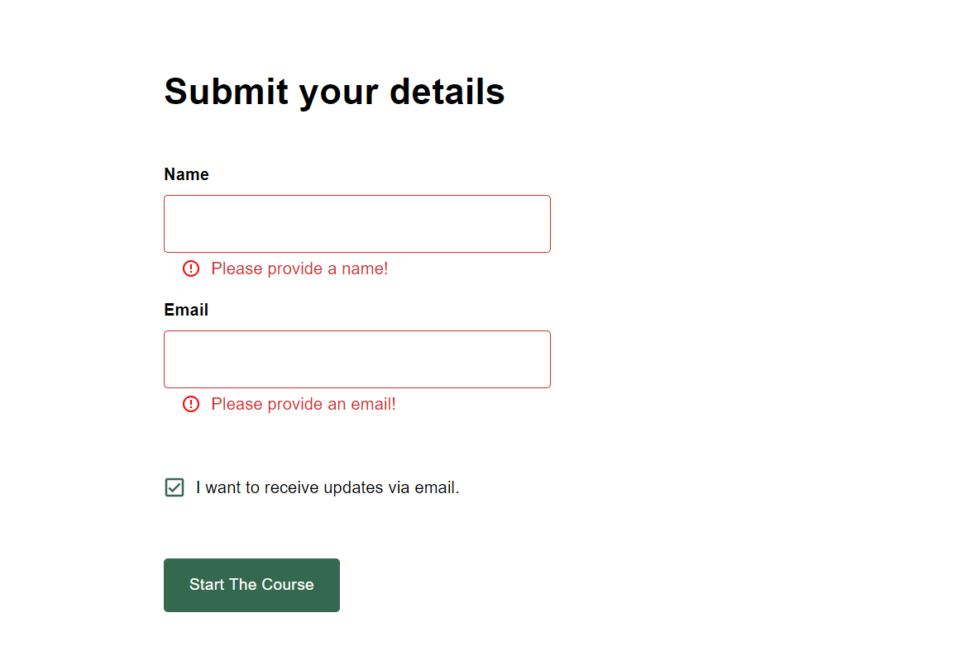

**=> if email is not valid**

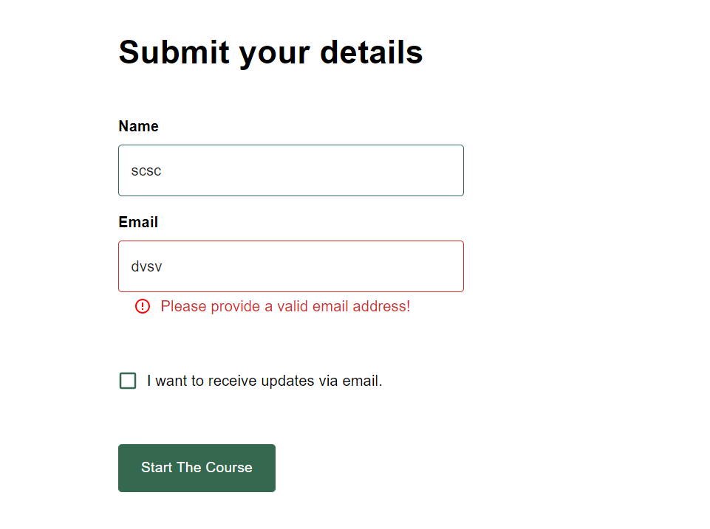

**=> After submit will display api error response else will redirect to ‘/dashboard’**   
